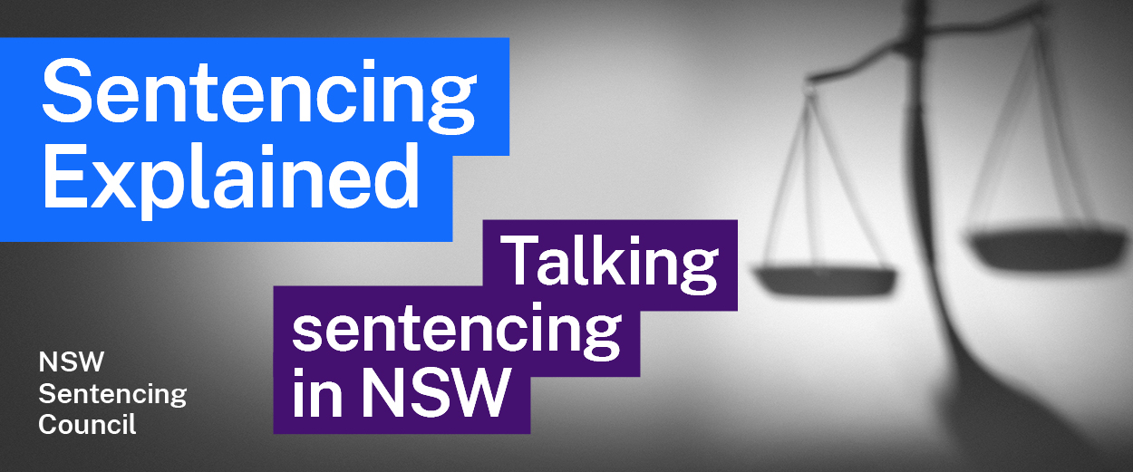Episode 15 Study Guide
Exploring victims’ rights and experiences in sentencing with Professor Tracey Booth

Background
- Visit Professor Booth’s academic profile. What are her main areas of research?
- What led to Professor Booth’s interest in victims and the law?
- According to Professor Booth, where do victims fit in the criminal justice system?

History of the role of victims in the criminal justice system
- According to Professor Booth, how did the criminal justice system change in the 19th century? How did this change affect the role of victims?
- How does Professor Booth explain the role of fairness in our criminal justice system?
- According to Professor Booth how did
- feminism in the 1960s and 1970s, and
- victim activists
help change the role of victims in sentencing?

Victim impact statements
- When were victim impact statements introduced in New South Wales?
- How were victim impact statements originally presented to the court? What changed in 2003?
- What two classes of victims can give victim impact statements? How has this changed over time?
- Describe the instrumental and expressive functions of a victim impact statement.
- How have victim impact statements in homicide cases changed? According to Professor Booth, what difference has this made?

Trauma and the criminal justice system
- According to Professor Booth, what is a “trauma-informed court”?
- Professor Booth describes the experience of a mother who made a victim impact statement about her son’s murder. In Professor’s Booth’s view, how could this have been handled better?
- What are some of the issues with the cross-examination of victims of violent crimes?
- Professor Booth mentions the Netherlands has a civil, “inquisitorial” legal system. How is this different to our common law, “adversarial” system?
- What changes to sentencing hearings would Professor Booth like to see?

Further resources and activities
- The United Nations and European Union declarations on protecting victims’ rights:
- 1985 Declaration of Basic Principles of Justice for Victims of Crime and Abuse of Power
- 2012 The Victims' Rights Directive
- The Sentencing Council’s 2018 report on victims' involvement in sentencing.
- These two sites have information on victim support:
- Office of the Director of Public Prosecutions Victims & Witnesses services
- Victim Services at NSW Department of Communities and Justice.
- The Judicial Commission’s publication on trauma-informed courts guides judges about trauma-informed practices.
- The HSC Legal Studies exam includes questions on victim impact statements. Visit the Sentencing Council’s website to test your knowledge on this issue. Questions on victim impact statements are included in the 2011, 2014, 2015, 2018, 2019 and 2021 exam question examples on the Council’s website.

