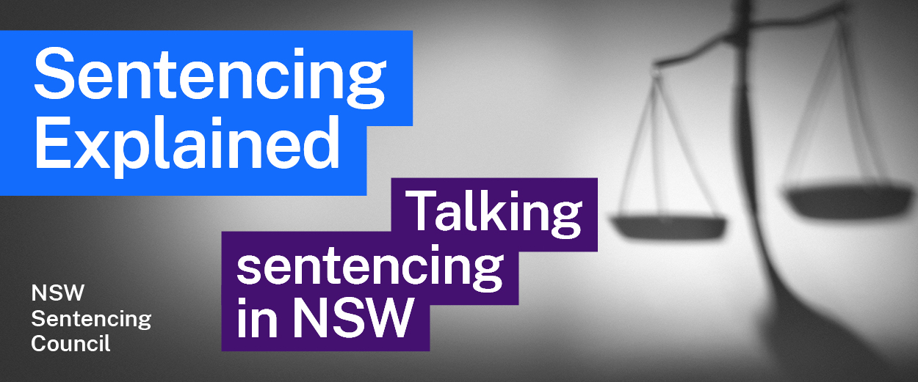Episode 17 Study Guide
Circle Sentencing with Maree Jennings

Background
- Explain what is meant by the term “restorative justice”.
- How did Maree get involved in Circle Sentencing?
- Explain the structure of Circle Sentencing.

Assessment and eligibility
- What types of offences come before a Circle?
- Explain the assessment process, including:
  - the role of the Aboriginal Community Justice Group, and
  - what happens if an offender is determined to be suitable or not suitable for the Circle.

Process and roles
- Describe how the Circle operates once it is formed.
- How long is usually allowed for a Circle hearing?
- Describe the roles of the following members of the Circle Sentencing Group:
  - magistrate
  - offender
  - respected community members, and
  - victim/s (if present).
- Who are the respected community members on a Circle? How are they selected? What informs this choice?
- Describe the role of the Project Officer in organising the Circle.
- Community members in Circle Sentencing are volunteers. What do you think are the pros and cons of this?
- How does Circle Sentencing contribute to the sentencing purpose of rehabilitation?
- How is a sentencing recommendation made? Who makes it? Is the Magistrate bound to accept the sentencing recommendation?

Circle Sentencing outcomes and expansion
- Once an offender goes through a Circle, is there any follow-up?
- What benefits does Maree see from Circle Sentencing? Why does she see community involvement in the criminal justice system as a positive?
- Maree mentions the 2020 BOCSAR (Bureau of Crime Statistics and Research) evaluation of Circle Sentencing. What findings from the report did Maree highlight?
- In Maree’s view, how do Aboriginal communities generally view Circle Sentencing?

Further resources and activities
The 2020 review of “Circle Sentencing, incarceration and recidivism” is available on BOCSAR’s website.

