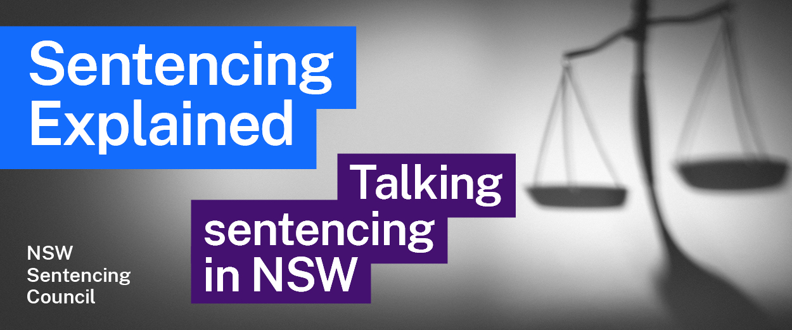
Sentencing Council Podcast 18

Aboriginal people and the criminal justice system with Magistrate Douglass

Early life and career
1. What jobs did Magistrate Douglass do after leaving school? Why did he decide to go to university and what path did he take to get there? What did he study?
2. Describe Magistrate Douglass’ career after graduating from university and before becoming a magistrate.

Career as a Magistrate
3. How and when was Magistrate Douglass appointed as a magistrate?
4. Where has Magistrate Douglass sat as a magistrate?
5. Describe the workload of a Local Court magistrate. What types of cases do magistrates deal with?

Aboriginal people and sentencing
6. Magistrate Douglass describes the law as being “flexible, particularly in relation to sentence”. Describe what a mitigating factor is and outline the example Magistrate Douglass provided.
7. Outline the issues Magistrate Douglass identifies as contributing to offending by young Aboriginal people.
8. Magistrate Douglass says he is “encouraged that many are now working towards finding new methods of trying to deal with, or new strategies to deal with Aboriginal offenders”. What is he referring to?
9. Outline the role of the following specialist processes and courts:
(a) Youth Koori Court
(b) Drug Court
(c) Coroner’s Court
10. What does Magistrate Douglass say could help overcome the disproportionate rates of Aboriginal people in custody?

Circle Sentencing and the First Nations Committee
11. Magistrate Douglass was present when Circle Sentencing began in 2002. What are his views on Circle Sentencing?
12. Magistrate Douglass observes that a Circle Sentencing process may take 1 or 2 hours, while sentencing in the Local Court may only take 5 minutes. Why is this distinction important?
13. What is the Local Court’s First Nations Committee? What are some of its current and recent activities?

Further resources and activities
- More information on the Aboriginal Legal Service can be found on the ALS website.
- This infographic by the Bureau of Crime Statistics and Research provides an overview of criminal court finalisations, including the workload of the different courts.
- For more information on the Walama List and Circle Sentencing, listen to Sentencing Explained podcast episodes 16 and 17.
- To learn more about the case of Munda v The State of Western Australia [2013] HCA 38, read a summary of the High Court’s judgment and further commentary on the case.

