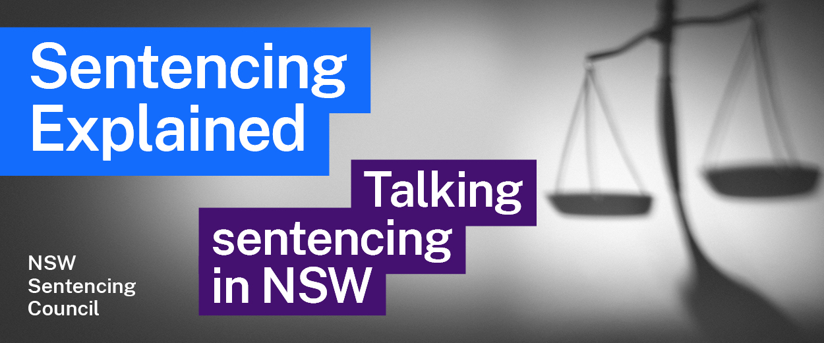Episode 19 Study Guide
Insights into parole with the Hon James Wood AO KC

Background to the Hon James Wood AO KC
- Outline Mr Wood’s career in the law.
- Mr Wood was the Chairperson of the NSW Law Reform Commission. Visit this webpage on the Commission’s law reform process. How does this process work?

The parole process
- How is the parole process different for offenders with sentences of less than 3 years, compared to offenders with sentences of over 3 years?
- What happens 60 days before an offender’s parole date? This page about how parole is considered may help with your answer.
- Who sits on a State Parole Authority (SPA) panel? See this page on SPA members.
- What decisions can the SPA make when they consider whether to grant parole?
- What options does an offender have if they have been refused parole? When are these options available? This page on refusing parole may help.
- What role do victims have? See this page on victims and parole.
- What is the role of the Prisoners Legal Service? The Prisoners Legal Service website has more information.

Parole conditions
- Offenders on parole must comply with 11 standard conditions, as well as any additional conditions imposed. Have a look at these conditions on the SPA’s website.
  - Why do you think all parolees have to comply with the standard conditions?
  - Why would the SPA impose additional conditions? Use examples.
- What happens if an offender breaches a condition? What role does the SPA play after a breach? See this page on breaches of parole.
- What happens if an offender commits another offence while on parole?

Reintegration home detention orders
This page on reintegration home detention orders will help with your answers to this section.
- What is a reintegration home detention order? When are these imposed?
- People on reintegration home detention orders are placed on electronic monitoring. How does this work?
- What happens when an offender who successfully completes their period of reintegration home detention?
- Go to the page 22 of the SPA’s 2021 annual report and see the statistics about reintegration home detention orders. What do these statistics show?

The SPA and intensive correction orders
- Mr Wood mentions that the SPA deals with intensive correction orders (ICOs). What is an ICO? What role does the SPA play with these orders?
- Go to the snapshot of SPA decisions on page 18 of the SPA’s 2021 annual report. How many ICOs were revoked in 2021?

Further resources and activities
- Access the NSW Bureau of Crime Statistics and Research’s interactive Custody Statistics website for statistics on people in custody.
- The State Parole Authority publishes some of their parole determinations for high profile offenders. See this page on the SPA’s parole determinations to access these decisions to see how the SPA approaches parole decisions.
- Read the SPA’s 2021 annual report for more information on the SPA’s work.
- Mr Wood has worked across many areas of the law, including the NSW Police Royal Commission, Police Integrity Commission, Special Commission of Inquiry into Child Protection Services in NSW and the World Anti-Doping Agency. You may wish to search for more information about his work in these areas.

