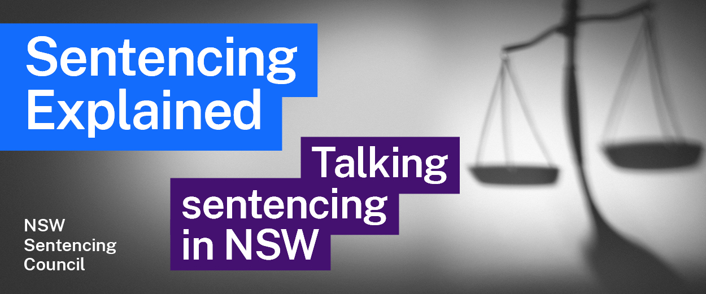Episode 13 Study Guide
Spotlight on the appeals process with Justices Robert Beech-Jones and Derek Price

Background
- Describe the structure of the Supreme Court. The Supreme Court’s webpage about the Court may help you with your answer.
- What criminal matters are heard in the Supreme Court?
- Are all murder trials heard by a jury? Why or why not?

Sentence appeals in the Court of Criminal Appeal
- What does “seek leave to appeal” mean? How does this work practically?
- What are the three broad grounds of sentence appeals to the Court of Criminal Appeal?
- The prosecution can appeal a sentence on certain grounds. What is the most common ground? What three things does the Crown ordinarily have to show in such an appeal to be successful?
- If an offender brings a sentence appeal in the Court of Criminal Appeal, can the Court increase the sentence? In such an appeal, what process does the Court need to follow if it thinks the sentence is too high?
- In a sentence appeal, can the Court of Criminal Appeal look at the circumstances of the convicted person at the time of the appeal, or can it only consider their circumstances at the time they were originally sentenced?

Other appeals in the Court of Criminal Appeal
- In a conviction appeal, what options are available to the Court of Criminal Appeal? Explain what happens with each option.
- When can the Supreme Court hear appeals from the Local Court? See Part 5 of the Crimes (Appeal and Review) Act 2001 (NSW).
- If a re-trial is ordered in a sexual assault case, what options are available for the evidence of complainants?

Bail when waiting for an appeal
- What is the test for bail for a person who is waiting for their appeal heard by the Court of Criminal Appeal? Is it common for bail to be granted in these circumstances?
Appeals in the District Court
- What type of appeals does the District Court hear from the Local Court?
- What is a “de novo” hearing in the District Court?
- When the District Court hears a sentence appeal, what decisions can it make?

Further resources and activities
- Learn more about the Supreme Court at the Supreme Court website.
- Learn more about the District Court at the District Court website.

