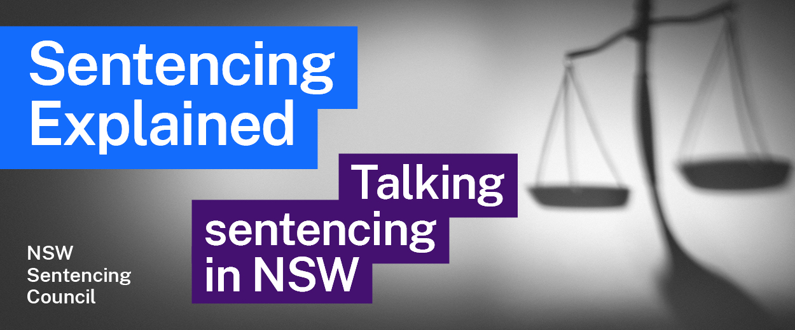Episode 14 Study Guide
Prison and community corrections with
Peter Severin, former Commissioner of Corrective Services

Background
- What is Mr Severin’s background in Corrective Services?
- What two main areas is the Commissioner of Corrective Services responsible for?
- What is the role of the pre-sentence report service?
- What are the Corrective Services Industries mentioned by Mr Severin? See this factsheet on Corrective Services Industries to find out more about how this works.

Prison
- What is the process after a person is sentenced to prison? Start your answer from when the person leaves the courtroom.
- Describe the classification process for a prisoner entering custody. This factsheet on classification and placement may help with your answer.
- What happens at a prisoner’s annual formal reassessment? Why is it helpful for the prisoner to have a positive review?
- How is daily prison life different for a prisoner classified as a maximum security inmate, compared to inmates classified as medium and minimum security inmates?
- According to the most recent NSW Bureau of Crime Statistics and Research custody statistics, how many adult prisoners are in prison? What percentage are:
  - Aboriginal?
  - On remand? This means a prisoner who is being held in custody while waiting for their trial or custody.
  - Female?
How do these compare to the statistics referred to by Mr Severin as of March 2022?

Prisoners’ needs and programs to address these
- According to Mr Severin, what kind of trauma may prisoners have experienced before entering the prison system?
- What does Mr Severin mean by “gender-specific needs”?
- How does the prison system cater for the needs of Aboriginal and Torres Strait Islander people?
- Describe some of the programs that are available to inmates. This factsheet on education programs and this factsheet on other programs may help with your answer.
- What are some of the services aimed at welfare available to inmates?

Parole and custodial supervision
- When is an offender automatically given parole?
- What are the different reports that Community Corrections prepare for an offender who might be eligible for parole?
- Describe the assessment process for a prisoner before they are released on parole.
- When might electronic monitoring be used for parole? How does it work?
- Explain the role of Community Corrections in supervising these orders:
  - Intensive Corrections Order
  - Community Corrections Order
  - Conditional Release Order
In your answer, include a brief description of each order. This factsheet on factsheet on community based orders may help with your answer.
- How are breaches of each of these orders dealt with?

Further resources and activities
- See the Corrective Services NSW website to find out more about what they do.
- Download this factsheet on Community Corrections to learn more about their role in the criminal justice process.

