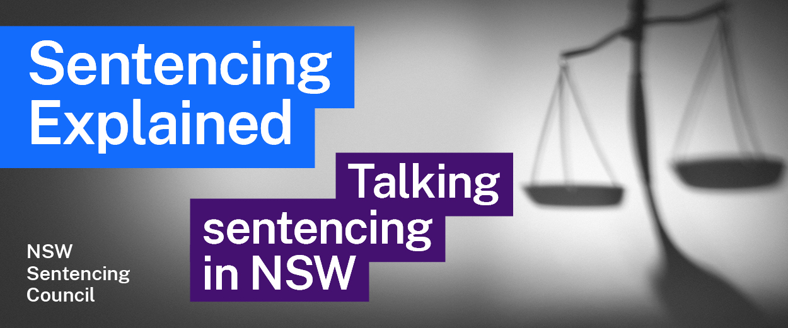Episode 2 Study Guide
Perspectives from the Sentencing Council
with Howard Brown OAM and Moira Magrath

The victims’ movement
- Howard Brown describes “the victims’ movement”. What is it and why was it seen as important in the sentencing debate?
- Howard mentions other victim advocates from that time, Ken Marslew and Martha Jabour. Howard, Ken and Martha all established victim support groups. What is the role of each of these organisations?
Victims of Crime Assistance League (VOCAL) www.vocal.org.au
Enough is Enough www.enoughisenough.org.au
Homicide Victim Support Group www.hvsgnsw.org.au

Functions of the Sentencing Council
- Howard and Moira talk about the high-profile people they met on the Sentencing Council. Visit the Sentencing Council’s website and note who is on the Council now.
- What is the Sentencing Council’s role?
- What were some of the major issues that motivated the early members of the Sentencing Council?

Sentencing reforms and addressing the purposes of sentencing
- Howard talks about the “move politically towards mandatory sentencing”. Why was this so concerning?

- What are some of the major problems associated with short-term sentences?
- Consider Howard’s comment, set out below. What does it reveal about the process of law reform?
.. what we had to do as a Sentencing Council was not only to identify what the problems were, but to find a process which politicians would be satisfied that they could actually sell to the electorate. And so it took a great deal of work and a great deal of statistical data to put the information together to say: this is why we say the system doesn’t work. And surely you want a person whose criminogenic needs are met, because then they’re not going to reoffend, and if they’re not going to reoffend, then you’re not going to have another victim. And surely that’s what we're aiming for.
- Moira talks about the “best practice in corrections shift that was happening internationally”. What was this shift, and why was it important?
- Consider Moira’s comment, set out below. What does it reveal about the role of community corrections officers?
… it’s very difficult to sit with an offender who has murdered someone, or sexually assaulted a child, or whatever they’ve done and dwell on the victim. To safeguard yourself emotionally you need to focus on the offender and the job that needs to be done by the offender and with the offender … to prevent another victim, or to at least reduce the likelihood …
- What was periodic detention? Why does Howard believe the removal of periodic detention was a highlight of his time on the Council?

Further resources
- Sentencing Council reports: Abolishing Prison Sentences of Six Months or Less (2004); Review of Periodic Detention (2007); Public Confidence in the NSW Criminal Justice System (2009); Victims’ Involvement in Sentencing (2018).
- Meet the NSW Sentencing Council (Sentencing Council webpage)
- About us (Sentencing Council webpage)

