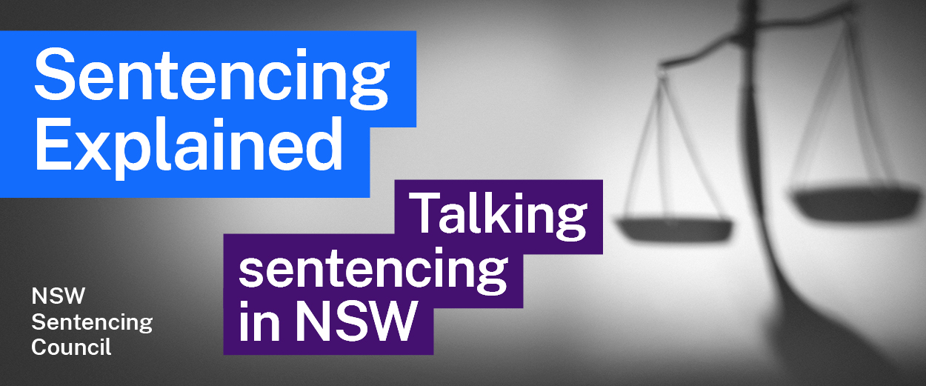Episode 5 Study Guide
Stepping through sentencing in the Supreme Court with Justices Adamson and Hulme

Key concepts
- How does Acting Justice R A Hulme (Justice Hulme) describe the purposes of sentencing? For more information, see section 3A of the Crimes (Sentencing Procedure) Act 1999 (NSW).
- Justice Hulme says, “we are required to impose a sentence that is proportionate to the seriousness of the offence in question”. What does his Honour mean by this?
- Section 21A of the Crimes (Sentencing Procedure) Act 1999 (NSW) sets out the aggravating, mitigating and other factors to be considered in sentencing.
  - How do Justices Hulme and Adamson describe these factors?
  - Why does Justice Adamson find remorse such a strong mitigating factor when considering an appropriate sentence?
  - Why does Justice Adamson find whether an offender has been involved in planning an offence an important factor in determining a sentence?
- What are standard non-parole periods (SNPPs)? How do Justices Hulme and Adamson explain the impact of SNPPs on the sentence their Honours may impose?
- What is the result of a finding of special circumstances? Why might a sentencing judge make such a finding? Why is this important?
- Why does Justice Hulme see a period on parole as important?

The sentencing hearing
- What are agreed facts, which Justice Adamson mentions?
- What reports or evidence may be tendered at a sentencing hearing?
- What is the role of victim impact statements (VIS) at a sentencing hearing?
- Justice Adamson says that it is rare to see a VIS in cases involving certain offences. What are those offences? Why do you think it would be rare to have a VIS in those cases?
- Why might it be important for the family of the deceased to have the opportunity to give a VIS in a murder trial?
- Justice Adamson explains some of the reasons why there may be a delay between a guilty verdict (or plea of guilty) and the sentencing hearing. What are these reasons?

Making a sentencing decision
- Why might a judge find it confronting when considering a sentence?
- When Justice Adamson says that the maximum penalty is “a guidepost for cases in the worst category”, what does her Honour mean? When might the maximum penalty be imposed?
- According to Justice Hulme, what are guideline judgments and why were they introduced? How are they used in sentencing? Why did the High Court criticise their use?
- Justice Hulme mentions two valuable contributions to sentencing made by the Judicial Commission. What are they? How does Justice Hulme use them in the sentencing process?
- How are the head sentence and non-parole period calculated?

The community and sentencing
- Why does Justice Adamson challenge people to read the reasons for sentence?
- What issues does Justice Hulme identify in media reports of sentencing?

