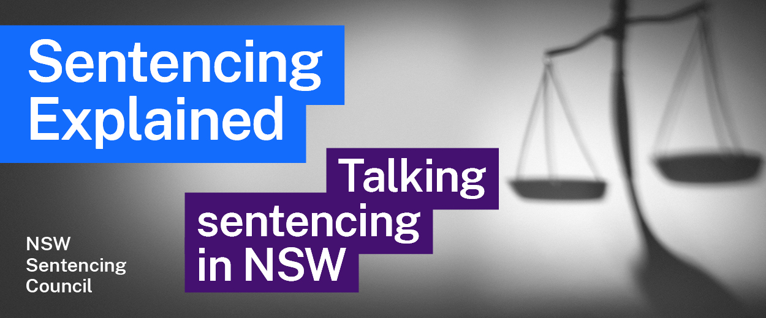Episode 7 Study Guide
A look at Legal Aid and sentencing with Director Robert Hoyles

Background to Legal Aid
- Robert is the Director of Crime for Legal Aid NSW (Legal Aid). What does his job involve?
- What is the means test for Legal Aid? Why does it exist? Find out more about the means test in the Legal Aid NSW policies.
- What services does Legal Aid provide in the Local Courts across NSW? Why is this service crucial to the delivery of justice?

Role of Legal Aid
- If an individual is refused police bail and held in custody overnight, what role does Legal Aid play?
- How do people attending court know there is a Legal Aid solicitor at the court?
- What does the Legal Aid solicitor do in the first meeting with the client on the list day? At this time, who represents the prosecution?
- Why may it be difficult for Legal Aid to provide continuity of representation?
- What is the relationship between Legal Aid and the Public Defenders?
- Why may the representation provided by Legal Aid in the Local Court be different to that provided in the District and Supreme Courts?
- Legal Aid handles appeals from the Local Court to the District Court and to the Court of Criminal Appeal. What is the merit test and how is it applied?

The criminal process
- What is the special caution, in relation to the right to silence? What are the requirements around issuing a special caution?
- Reforms to the law on Early Appropriate Guilty Pleas (EAGP) came into effect in 2018. What can happen now if an individual pleads guilty to an indictable offence? You can find more information on the EAGP process on the website of Legal Aid NSW.
- Why is the Case Conference Outcome Certificate so important?
- What is the full discount on sentence that is available? Provide an example of when the accused would get the full discount.
- What are some difficulties with calling the accused to give evidence in a criminal trial?
- Who bears the onus of proof in a criminal case? What is the standard of proof?

Sentencing hearings
- How do Legal Aid representatives approach a sentencing hearing for someone who has been found guilty? How does this differ if the person has pleaded guilty?
- Why does Robert find it “far more challenging” to represent a person who has been found guilty (rather than someone who has pleaded guilty) in a sentencing hearing? What examples does Robert provide?
- What does Robert consider when deciding whether to call the offender to give evidence at a sentencing hearing?

Sentencing Aboriginal offenders
- Why is it so important for judges to consider the principles in Fernando and Bugmy when sentencing Aboriginal offenders?
- How is Legal Aid involved in representing Aboriginal offenders in Circle Sentencing (Local Court) and in the Walama List (District Court)?
- How does Robert describe the Circle Sentencing process?

