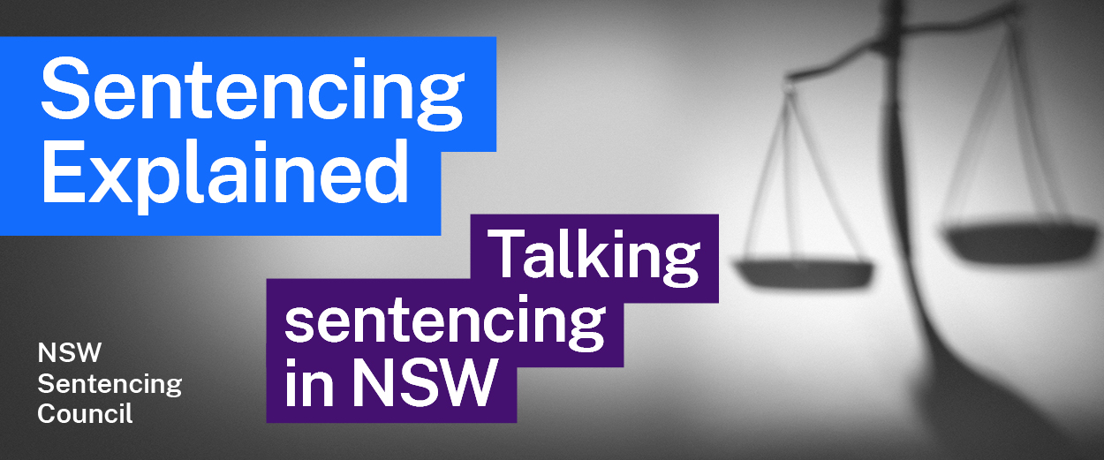Episode 12 Study Guide
Delving into the Drug Court with Senior Judge Jane Mottley

Background
- When was the Drug Court established?
- How many judges sit on the Drug Court? Where does the Drug Court sit?

Referral and processes
- Explain the process for an offender appearing before the Drug Court.
- What information must an offender (via their legal representative) provide to the court to show that they should referred to the Drug Court program?
- Look at s 6 of the Drug Court Act 1998 (NSW) and explain what Judge Mottley means by: “The magistrate has no discretion. It's a duty, and so ultimately then it's for the Drug Court to determine the ultimate question of eligibility after other considerations are brought.”

Eligibility assessment and selection
- Judge Mottley mentions “eligibility criteria”. Follow the link and summarise the “eligibility criteria” mentioned by Judge Mottley.
- Judge Mottley explains that an offender must live within the catchment area of the established Drug Courts to be eligible. What are the consequences of this?
- What role does the Director of Public Prosecutions (DPP) play in establishing an offender’s eligibility for the Drug Court?
- The Drug Court operates on a ballot process. Why is this the case? What happens if an offender misses out?
- Outline what happens at an “initial referral” after an offender succeeds in the ballot. What role does the DPP play in that process?

Treatment and Case Management Plan and initial sentence
- What is the Treatment and Case Management Plan? Who prepares it?
- Before the initial sentencing hearing, what assessments are done to explore an offender’s accommodation while in the program? If it is determined that the offender can’t live in the community without support, what options are there?
- What is the process for an offender receiving an initial sentence in the Drug Court? What role does the initial sentence play in the Drug Court program?

The program
- What conditions are imposed on an offender when they enter the program?
- What role does the offender’s parole officer play in the program?
- Why is the Centrelink exemption important?
- What happens when an offender does not comply with the requirements of the program (for example, by failing a drug test)?
- When an offender progresses to Phase Two, what are they encouraged to do? When they progress to Phase Three, what does their program look like?
- What are the requirements for an offender to graduate the Drug Court program?
- What happens at graduation? When an offender graduates, what happens to their initial sentence?
- What is the process for offenders who only reach Substantial Achievement?
- How is the Indigenous List run in the Drug Court?
- How does Judge Mottley reflect on the success of the Drug Court program? Why does her Honour find the work so rewarding?

Further resources
- See the NSW Bureau of Crime Statistics and Research (BOCSAR) report on the long-term effect of the NSW Drug Court on recidivism.
- For more information about the Drug Court, visit Drug Court website and the Drug Court Act 1998 (NSW).

