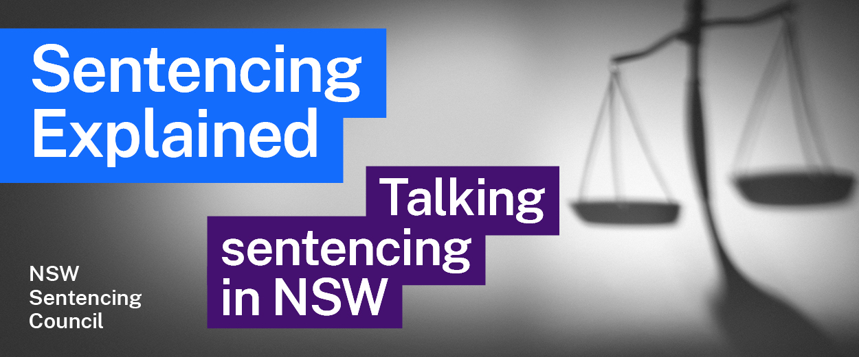Episode 3 Study Guide
The role and duty of a prosecutor with
Director of Public Prosecutions Sally Dowling SC

Key concepts
- What is the difference between summary and indictable offences? Why is this important?
- Trials for indictable offences are usually heard by a judge and jury in the District or Supreme Court. However, some cases are heard by a judge without a jury (this is called a “judge alone trial”). What are the benefits and disadvantages of a judge alone trial? Why might an application for a judge alone trial be made?
- What are “plea negotiations”?
- What is a statement of agreed facts? Why is it an important part of the sentencing process?
- Why is it uncommon for an offender to give evidence at a sentencing hearing?
- The two pillars of sentencing are the “objective seriousness of the offence” and the “subjective circumstances of the offender”. What do they mean? How are they used when determining an appropriate sentence?
- Section 5 (1) of the Crimes (Sentencing Procedure) Act 1999 (NSW) states:
A court must not sentence an offender to imprisonment unless it is satisfied, having considered all possible alternatives, that no penalty other than imprisonment is appropriate.
Why is this important?

The role, purpose and function of the prosecution
- Visit the website of the Office of the Director of Public Prosecutions (ODPP): www.odpp.nsw.gov.au. What is the role of the ODPP and the Director of Public Prosecutions (DPP)?
- What offences does the ODPP mainly prosecute?
- What is the function of the prosecutor during the sentencing process?
- What is the role of the ODPP after an offender pleads guilty?
- Sally mentions the importance of managing the mental health of her prosecutors. How does the ODPP seek to do this?

Victims and witnesses
- The ODPP does not represent the victim during a trial, however the ODPP does play a role in supporting victims. How does it do this?
- What is a Victim Impact Statement (VIS)? Why are they important?
- How does the ODPP help victims with their VIS?
- If the victim is unable to read their VIS at trial, who can read it on their behalf?
- What is the role of the Witness Assistance Service within the ODPP?

Crown appeals on sentence
- When can the ODPP appeal a decision from the District or Supreme Court?
- When can the Crown appeal a decision of the Court of Criminal Appeal to the High Court?

Further resources and activities
- Annual Report of the Office of the Director of Public Prosecutions
- See the Prosecution Guidelines, issued by the Director of Public Prosecutions, which set out some general principles relevant to prosecuting criminal proceedings
- Sentencing Council’s 2018 Report on Victims’ Involvement in Sentencing
- Crimes (Sentencing Procedure) Act 1999 (NSW) Div 2
- Visit the Victims and Witnesses section of the ODPP website.

